Novel Nights: Jane Shemilt 20th November
daughter

"Naomi is still missing...Why should I be comfortable?"

- sold to 14 countries
- Sunday Times Bestseller
- Richard & Judy Book Club Choice

Jane will talk about writing, giving up work to write and her debut novel

“Absolutely captivating”…“Extremely intelligent…thoughtful”…“Damn good thriller… surprising” (Richard and Judy)
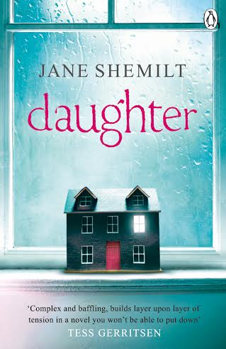
“Absolutely captivating”…“Extremely intelligent..thoughtful”…
“Damn good thriller… surprising” (Richard and Judy)
Tickets £4 on the door or www.wordpoppy.com
The Lansdown, Clifton, Bristol BS8 1AF
Doors 7.30 starts 8pm sharp
with readings from Fiona Longsdon & Mina Bancheva
With readings from Fiona Longsdon and Mina Bancheva

